**ATAR CHEMISTRY – UNIT 3  
TASK 7 – Oxidation and Reduction Test**

**TOTAL MARKS:**

**/33**

**NAME: _______________________**

Answer all multiple choice answers on the slip of paper provided. Clearly write your short and extended answers in the space provided below. Where applicable show all working out and round final calculations to appropriate significant figures.

MULTIPLE CHOICE (14 marks)

1. Which one of the following pairs of statements is correct for both electrolysis cells and galvanic cells?



|  |  |
| --- | --- |
| **Electrolysis Cell** | **Galvanic Cell** |
| Both electrodes are always inert. | Both electrodes are always made of metal. |
| Electrical energy is converted to chemical energy. | The voltage of the cell is independent of the electrolyte concentration. |
| Chemical energy is converted to electrical energy. | The products are dependent on the half-cell components. |
| The products are dependent on the half-cell components. | Chemical energy is converted to electrical energy. |

1. Which of the following statements about oxidising and reducing agents is false?
2. Bromine water can oxidise chloride ions to chlorine.
3. Hydrogen peroxide solution is capable of spontaneous self oxidation - reduction.
4. Group I metals are good reducing agents.
5. Copper metal will react with a dilute silver nitrate solution.
6. Regarding the corrosion of iron, which of the following statements is **not** correct?

* + 1. The solid Fe loses electrons.
    2. The oxidation number of O2 is decreased.
    3. Precipitation of Fe(OH)2 by combination of Fe2+ with OH- is not a redox process.
    4. The H2O acts as the oxidising agent.

1. Using the standard reduction potential table, which statement is correct?
   * 1. Sodium is more likely to be oxidised than zinc.
     2. Magnesium is more likely to be reduced than copper.
     3. Iron will react in a solution of magnesium nitrate.
     4. There will be a reaction if magnesium is placed in sodium nitrate.

**Question 5 refers to the diagram and the equations below.**

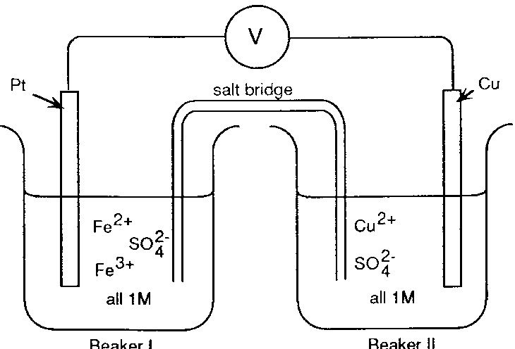

BEAKER I

BEAKER II

|  |
| --- |
| Fe3+ + e‾ Fe2+ E0 = 0.77 V  Cu2+ + 2e‾ Cu E0 = 0.34 V |

1. If the salt bridge contained KNO3 solution, the:
   1. K+ ions move from beaker I and are replaced by Cu2+ ions.
   2. NO3‾ ions migrate into beaker I and are replaced by SO42‾ ions from beaker II.
   3. K+ ions move into beaker II and NO3‾ ions move into beaker I.
   4. K+ ions move into beaker I and NO3‾ ions move into beaker II.
2. A student made the following observations:
3. clean metal A did not react with 1.0M B2+
4. clean metal B dissolved in 1.0M C2+ and crystals of C appeared
5. Clean metal C did not react with 1.0M A2+

The order of strength as a reducing agent is

1. A > B > C
2. A > C > B
3. B > C > A
4. B > A > C
5. An electrochemical cell based on the following reaction has an E0 = 1.03 V

Cl2 + 2V3+ + 2H2O à 2VO2+ + 4H+ + 2Cl-

What is the standard reduction potential for VO2+ to V3+?

1. -3.05 V
2. -0.33V
3. +0.33 V
4. +3.05V

**Question 8 refers to the following data:**

1. The weakest reducing agent is

|  |  |  |  |
| --- | --- | --- | --- |
| * + 1. Be2+ | * + 1. Co2+ | * + 1. Cr3+ | * + 1. Co3+ |

1. Which metal would be **the best** choice as a sacrificial anode to prevent the corrosion of iron?

|  |  |  |  |
| --- | --- | --- | --- |
| * + 1. Lead | * + 1. Copper | * + 1. Zinc | * + 1. Magnesium |

1. The anode of an electrochemical cell is always

1. the site where electrons are lost.
2. the negative electrode.
3. the target of anion migration.

Which of these statements are **true**?

* + 1. (i) and (ii) only.
    2. (i) and (iii) only.
    3. (ii) and (iii) only.
    4. All of (i), (ii) and (iii).

1. Four metals Pb, *x,* *y* and *z*, were connected in pairs and the voltage was recorded.

The results obtained are set out in the table below.

|  |  |  |
| --- | --- | --- |
| ***Negative terminal*** | ***Positive terminal*** | ***Voltage (V)*** |
| Pb | *x* | 0.35 |
| *y* | Pb | 1.10 |
| *z* | Pb | 2.60 |

List the metals from **weakest** to the **strongest** reductant.

1. *z*, *y*, Pb, *x*
2. Pb, *x*, *y*, *z*
3. *x*, *y*, Pb, *z*
4. *x*, Pb, *y*, *z*

**Questions 12-14 refer to the following information.**

The Nissan Motor Corporation has developed cars that are powered by direct ethanol fuel cells (DEFCs). These fuel cells use bioethanol, made from sugar cane and corn, to produce electricity.

As shown in the simplified diagram below, ethanol, CH3CH2OH(l), enters the fuel cell and is converted to CO2(g) at electrode A. Air enters on the other side, and the O2(g) in the air is converted to H2O(l) at electrode B. These reactions take place in an acidic electrolyte.

1. This cell is classified as a fuel cell because

* + 1. it produces electrical energy from a spontaneous redox reaction.
    2. it has the potential to be branded as ‘zero net CO2 emission’ technology.
    3. it utilises the stored chemical potential energy within reactants to do work.
    4. it requires the reactants to be continuously fed into the cell.

1. Which of the following correctly assigns the polarity of electrode A and the direction of hydrogen ion, H+(aq), movement in the electrolyte?

**Polarity of electrode A** **Direction of H+(aq) movement**

* + 1. positive towards B
    2. positive towards A
    3. negative towards B
    4. negative towards A

1. The correctly balanced half-equation for the reaction occurring at electrode A is;

* + 1. CH3CH2OH(l)   +   H2O(l)   à    CO2(g)   +   8 H+(aq)   +   8 e-
    2. CH3CH2OH(l)   +   3 H2O(l)   à    2 CO2(g)   +   12 H+(aq)   +   12 e-
    3. CH3CH2OH(l)   +   H2O(l)   à    2 CO2(g)   +   8 H+(aq)   +   8 e-
    4. CH3CH2OH(l)   +   2 H2O(l)   à    CO2(g)   +   10 H+(aq)   +   10 e-

SHORT/EXTENDED ANSWER (19 marks)

1. Write any observations that would occur **after**:

(5 marks)

1. A strip of chromium metal is placed in a 1.00 molL-1 solution of cobalt(ii) nitrate.

______________________________________________________________________

______________________________________________________________________

1. Fluorine gas is bubbled into a solution of potassium chloride.

______________________________________________________________________

______________________________________________________________________

1. A piece of copper metal is placed in 2.00 molL-1 hydrochloric acid.

______________________________________________________________________

______________________________________________________________________

1. Mo3+ can be oxidized by potassium permanganate under acidic conditions to produce the molybdate ion (MoO42-). Manganese ions are also produce in the process.
2. Complete the table by writing balanced equations in the empty boxes.

(2 marks)

|  |  |
| --- | --- |
| Oxidation  Half-equation |  |
| Reduction Half-equation | MnO4-(aq) + 8H+(aq) + 5e- à Mn2+(aq) + 4H2O(l) |
| Overall Redox Reaction |  |

1. Use oxidation states to prove that the Mo3+ is being oxidized.

(1 mark)

1. The zinc-cerium battery is a commercial rechargeable battery that comprises a series of cells. During recharging the cells use energy from wind farms or solar cell panels. During discharging, energy is supplied to electric grids to power local factories and homes.

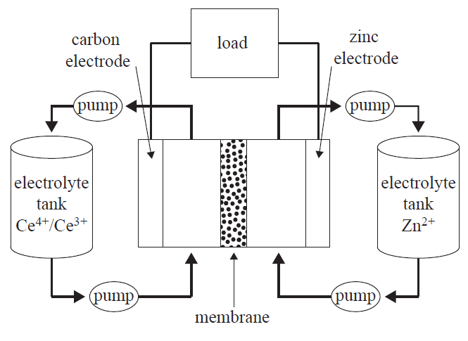

****The following half-cell reactions occur in the zinc-cerium cell.

1. Write the equation for the overall **discharge** reaction.

(2 marks)

________________________________________________________________

1. Identify the oxidising agent during **discharging** and justify your answer using oxidation numbers.

(2 marks)

________________________________________________________________

________________________________________________________________

________________________________________________________________

1. If a setup involved 3 cells, determine the theoretical voltage produced as they discharge.

(1 mark)

________________________________________________________________

1. Determine which electrode will be the cathode during the **recharging** process.

(1 mark)

________________________________________________________________

1. Fluorine, F2, gas is the most reactive of all non-metals. Anhydrous liquid hydrogen fluoride, HF, can be electrolysed to produce fluorine and hydrogen gases. Potassium fluoride, KF, is dissolved in the liquid HF to increase electrical conductivity.

F2 is used to make a range of chemicals, including sulfur hexafluoride, SF6, and excellent insulator, and xenon difluoride, XeF2, a strong fluorination agent.

The diagram below shows an electrolytic cell used to prepare F2 gas.

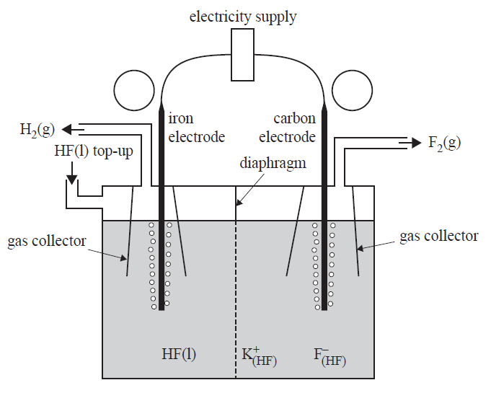

1. Label the polarities of each electrode in the circles provided on the diagram above.

(1 mark)

1. Write the equations for the half-reaction occurring at the anode.

(1 mark)

________________________________________________________________

1. Explain why the carbon electrode cannot be replaced with an iron electrode.

(3 marks)

________________________________________________________________

________________________________________________________________

________________________________________________________________

**END OF TEST**